**S-AES: required data:**

1. **Key generation:**

1. **Substitution Boxes:**

1. **mix column**

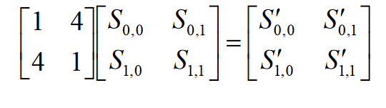

1. **Inverse mix column**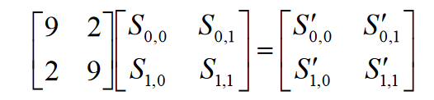
2. **GF multiplication table:**

1. **GF addition table:**